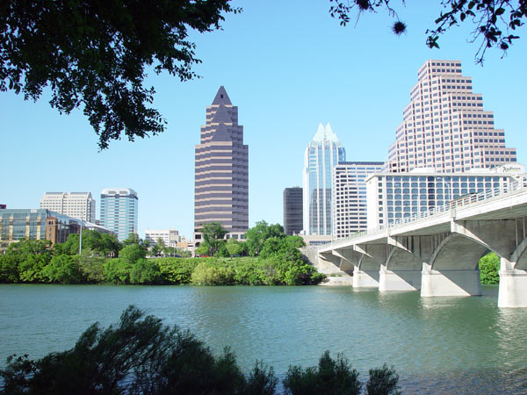  Trinity Center at St. David’s Episcopal Church  Location: 304 E 7th St, Austin, Texas 78701, Phone: (512) 617-0945, closed Saturday  The Trinity Center is a day shelter that provides financial assistance as well as many other services to clients of the shelter. At 9 A.M. on Tuesday and Thursday mornings, the shelter has a lottery for financial assistance (names are chosen at random to receive assistance). Anyone chosen to receive financial assistance will receive direct assistance from a case manager.  The shelter also serves breakfast everyday (except Saturdays) and has a religious service on Sunday mornings. In addition, on Monday mornings clients can “shop” for clothing that has been donated to the center (also based on a lottery system)  What to bring: nothing specifically, might be good to have ID, social security card, health care documents |  |  | Help Us Help You  We at the C.D. Doyle…  Care about your health. Please take advantage of these resources that are available to you!  C.D. Doyle  Phone: 512-610-3542  Address: 304 East 7th Street, Austin, TX 78701  C.D. Doyle does not endorse, nor is it affiliated with any of these programs/services. |  |  | Financial Assistance

Financial Assistance Programs for Medication (Austin, Texas)  Your Health MATTERS To Us  This brochure contains a list of programs in the Austin area that provide financial assistance for medication and health-care related co-payments.  We encourage you to take advantage of these resources because there are many programs that are ready to help!  All Saints Episcopal Church  Location: 209 W. 27th St., Gregg House (building behind church), Austin, Texas 78705, Phone: (512) 476-3589, closed Thursday  Arrive at 7 A.M. Tuesday mornings to place your name on the sign-up sheet for assistance. Arrive EARLY because assistance is given by a first-come-first-serve basis. Financial awards range from $15-$25, and you can only receive assistance once every 6 months.  What you need to bring: current photo ID |  |  | Baptist Community Center  Location: 2000 E 2nd St., Austin, Texas 78702, Phone: (512) 478-7243  Baptist Community Center provides assistance with medication co-payments. The center will maintain contact with your pharmacy (Walgreens, CVS, HEB, MedSavers) and cover co-payments for any prescriptions that you are unable to cover. The center will only provide assistance when the prescription is officially filed with the pharmacy. The center cannot cover your co-payments permanently. Call the center to set up an appointment to receive financial assistance.  What you need to bring: photo ID, social security card  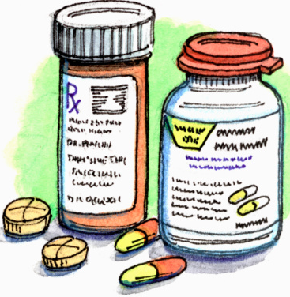 |  |  | 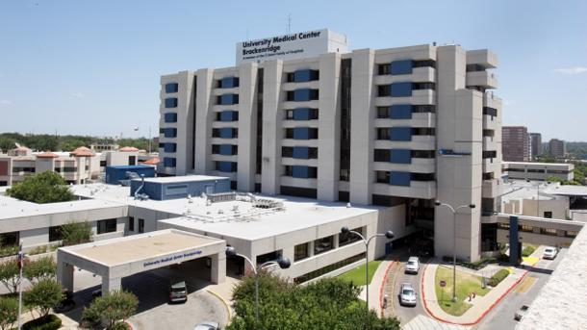  St. Austin Catholic Parish  Location: 2026 Guadalupe St., Austin, Texas 78705, Phone: (512) 477-9471, closed Saturday  The parish only provides assistance on a case-by-case basis. A lottery is held every Thursday at 9 A.M. (arrive earlier for best chance). 60-80 people come and up to 20 of those people will receive assistance. Financial award depends on your situation. Assistance is more readily given to patients with life threatening illnesses (diabetes, heart conditions). The parish also provides assistance for rent utilities. IDs, birth certificates, eyeglasses, eye exams, clothing, food vouchers, 7-day bus passes.  What you need to bring: nothing specifically, might be helpful to bring ID and social security card  Important Information  Many churches in the Austin diocese are usually willing to provide financial assistance for health-care related co-payments.  If you call the St. Austin Catholic Parish and provide your zip code, they can connect you to a church in your area that is willing to provide assistance.

